
RESEARCH PAPER ON
SUPERVISED LEARNING PROJECT
(OCT 2025 - DEC 2025)
On
Project Title:
PREDICTIVE ANALYSIS OF MEDICINE AND DOCTOR AVAILABILITY
Submitted by
Name | Registration Number
SAMBHAV JYOTI | 12411501
KRITI KUMARI | 12322865
SHRIOM ALHAWAT | 12408089
ANKUSH | 12320100

Under the Guidance of
MRS. GEETIKA SETHI
Assistant Professor,
School of Computer Science & Engineering

Lovely Professional University
Jalandhar - Delhi G.T. Road, Phagwara, Punjab (India) - 144411
Title: Predictive Analysis of Medicines and Doctor Availability Using Supervised Machine Learning

Abstract
Healthcare facilities frequently face challenges related to unexpected medicine shortages and unplanned doctor unavailability, both of which disrupt patient care and operational efficiency. This research presents a dual-predictive machine learning framework capable of forecasting both medicine availability and doctor availability using real-world hospital data. The study employs Random Forest, Logistic Regression, Gradient Boosting, and ensemble learning techniques, enhanced through SMOTENC to address the significant class imbalance present in mixed categorical–numerical datasets.
To ensure transparency and trust in clinical decision-making, the models are further interpreted using SHAP (Shapley Additive explanations), enabling granular insight into the key drivers behind predictions such as store stock, warehouse stock, expiry duration, department load, and scheduling patterns. Experimental results demonstrate that the soft-voting ensemble achieves superior predictive accuracy and reliability across both tasks, outperforming individual models.
The proposed framework shifts healthcare resource management from reactive to proactive by anticipating stock-out risks and predicting doctor unavailability before disruptions occur. This integrated, interpretable, and data-driven system offers a novel contribution to hospital operations, supporting smarter planning, reduced service delays, and improved patient outcomes.
Index terms: Supervised machine learning, ensemble prediction models, Shap, healthcare forecasting, time-series analysis, operational planning.
Table of Contents
Abstract 2
1. Introduction 2
2. Problem Statement 3
3. Objective 3
4. Methodology 4
6. Results and Findings 8
7. Future Work 10
8. Conclusion 11
9. References 11

Introduction
Efficient healthcare delivery depends on the continuous availability of essential medicines and the timely presence of doctors. However, hospitals and pharmacies often experience unexpected medicine shortages and unplanned doctor unavailability, leading to treatment delays and operational challenges. Traditional inventory and scheduling systems rely on manual estimation and cannot adapt to rapidly changing demand patterns.
Machine learning offers a powerful approach to address these limitations by enabling data-driven prediction of resource availability. While prior studies typically focus on either medicine stock forecasting or doctor scheduling, very few attempt to integrate both tasks within a single framework. Moreover, healthcare data is often imbalanced and contains a mix of numerical and categorical attributes, requiring specialized preprocessing and robust algorithms.
This research proposes a supervised machine learning framework to predict both medicine availability and doctor availability using hospital datasets. Models such as Logistic Regression, Random Forest, and Gradient Boosting are employed, and performance is enhanced using SMOTENC to manage class imbalance. To ensure transparency and trust, SHAP explainability is applied to identify the most influential factors behind predictions.
By combining predictive modeling with explainability, the proposed system enables hospitals to move from reactive to proactive decision-making. The framework provides a practical and innovative approach to reducing stock-outs, improving scheduling efficiency, and supporting overall healthcare resource management.

Problem Statement
Healthcare facilities frequently struggle with unpredictable medicine shortages and sudden doctor unavailability, leading to treatment delays, patient dissatisfaction, and operational inefficiencies. Traditional manual methods for monitoring stock levels and scheduling doctors are reactive, error-prone, and unable to account for complex patterns in patient demand or resource utilization. There is currently no integrated predictive system that can forecast both medicine availability and doctor availability using historical hospital data. Therefore, a data-driven, interpretable machine learning approach is needed to accurately predict resource availability in advance and support proactive healthcare planning.

Objective
The primary objective of this research is to develop an integrated predictive framework capable of forecasting both medicine availability and doctor availability within healthcare systems. To achieve this, the study focuses on the following specific objectives:
- To design and preprocess healthcare datasets containing mixed numerical and categorical features, addressing missing values, outliers, and structural inconsistencies.
- To handle class imbalance present in availability outcomes using SMOTENC, ensuring fair and unbiased model learning.
- To develop and train supervised machine learning models such as Logistic Regression, Random Forest, and Gradient Boosting for predicting availability patterns.
- To construct a soft-voting ensemble model that combines multiple classifiers to improve predictive accuracy and model robustness.
- To apply SHAP explainability to interpret model behavior, identify the most influential features, and enhance the transparency of predictive decisions.
- To evaluate and compare model performance using accuracy, ROC–AUC, precision, recall, and other relevant metrics for both medicine and doctor availability tasks.
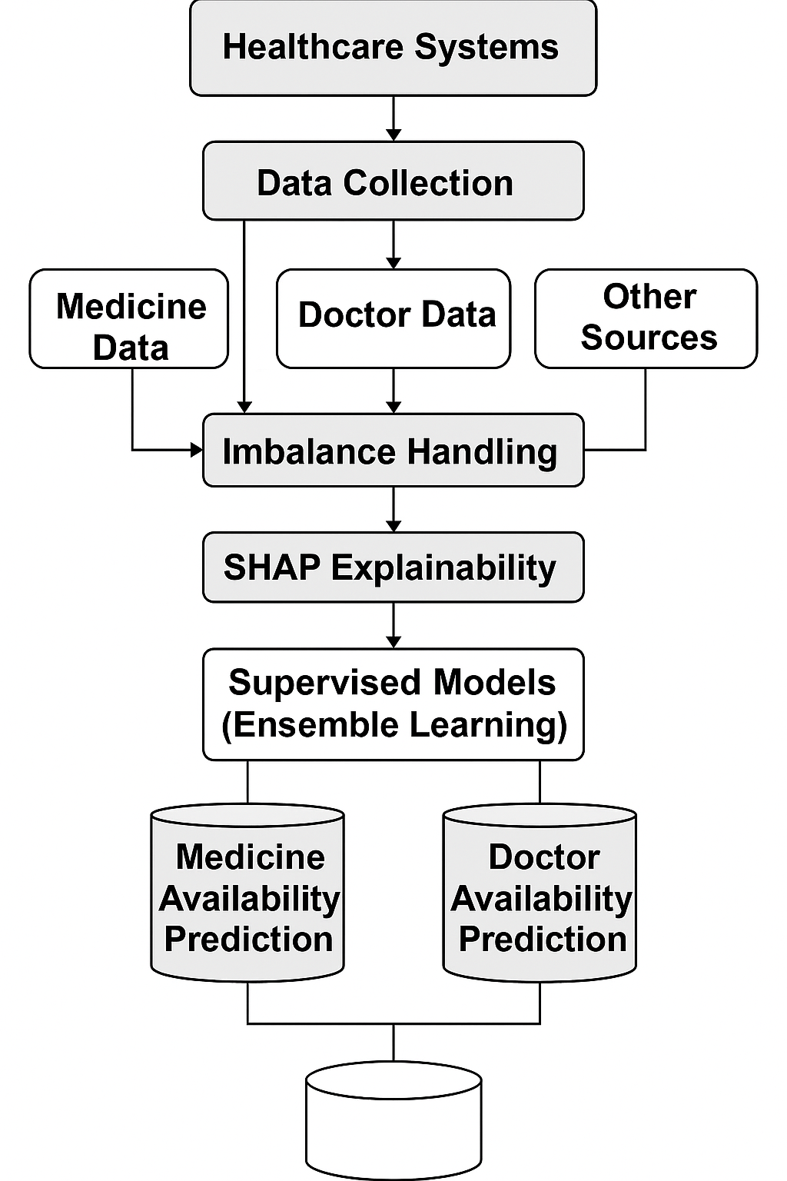
- To demonstrate a proactive healthcare management system capable of identifying potential stock shortages and doctor unavailability before disruptions occur.

Methodology
The methodology of this study is designed to develop a predictive system capable of forecasting both medicine availability and doctor availability. The process consists of six major stages: data preprocessing, feature engineering, imbalance handling, model training, ensemble construction, and explainability analysis.
  - Data Collection and Preprocessing
Medicine and doctor datasets were collected containing attributes such as stock levels, expiry days, pharmacy details, doctor schedules, departments, and availability status. Missing values were handled using median imputation for numerical features and categorical placeholders for text-based features. All features were separated into numerical and categorical groups for further processing.
4.2 Feature Encoding and Transformation
A Column Transformer was used to standardize numerical features and one-hot encode categorical features. This ensured that the machine learning models received consistent, fully numeric inputs. Outliers in stock and price values were treated using percentile-based clipping.
4.3 Handling Class Imbalance with SMOTENC
Both medicine and doctor availability datasets exhibited strong class imbalance. To prevent biased learning, SMOTENC was applied to oversample the minority class while respecting categorical feature boundaries. This improved model stability and predictive performance.
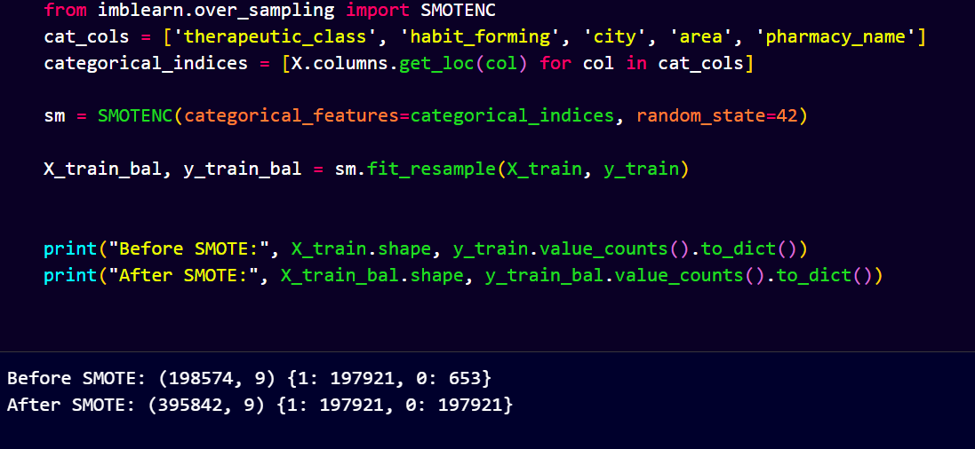
4.4 Model Training
Three supervised machine learning algorithms were trained:
- Logistic Regression:
Logistic Regression is a simple and effective classification algorithm used to model the probability of a binary outcome, such as medicine availability or doctor presence. It applies a sigmoid function to predict values between 0 and 1, making it suitable for early-stage prediction tasks. The model is lightweight, fast to train, and easy to interpret, which helps in understanding the basic relationships within the dataset.
- For Doctor availability
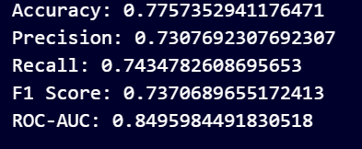

- For Medicine
Accuracy: 0.97
Precision: 0.99
Recall: 0.97
Roc_Auc:0.98
- Why Logistic Regression Was Used First:
- Baseline Model: Provides a clear reference to compare more complex models.
- Easy to Interpret: Helps identify early patterns and the effect of individual features.
- Fast Training: Suitable for quickly testing data quality and feature behavior.
- Probabilistic Output: Gives meaningful availability scores instead of just labels.
- Good Initial Diagnostic Tool: Reveals issues like imbalance, scaling, or noisy features before applying advanced algorithms.
- Gradient Boosting
Gradient Boosting is an advanced ensemble algorithm that builds a series of weak decision tree learners, where each new tree focuses on correcting the errors made by the previous ones. By combining many small models, it creates a strong predictor capable of capturing complex, non-linear relationships in the data. Gradient Boosting is well-suited for structured healthcare datasets and works effectively with mixed feature types.
- For Doctor availability
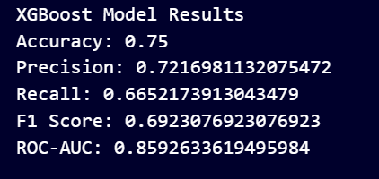
- For Medicine
Accuracy: 0.99
Precision: 0.99
Recall: 0.99
Roc_Auc:0.99
- Why Gradient Boosting:
- Captures Complex Patterns: Learns non-linear relationships that simpler models may miss.
- High Predictive Accuracy: Often outperforms individual models in classification tasks.
- Handles Mixed Data Well: Performs strongly with numerical and categorical features.
- Resistant to Overfitting (with tuning): Boosting reduces model variance and improves generalization.
- Complements Other Models: Provides diversity when combined with Logistic Regression and Random Forest in the ensemble
- Random Forest
Random Forest is an ensemble learning algorithm that builds multiple decision trees and combines their outputs to make a final prediction. Each tree is trained on a different subset of the data and features, which reduces overfitting and increases model stability. It is highly effective for classification tasks involving complex interactions and mixed feature types, making it ideal for healthcare prediction problems.
- For Doctor availability
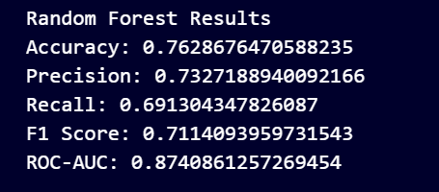
- For Medicine
Accuracy: 0.99
Precision: 1.0
Recall: 0.99
Roc_Auc:0.99
- Why Random Forest:
- High Accuracy & Stability: Performs well on real-world, noisy healthcare data.
- Handles Complex Patterns: Captures non-linear relationships better than simple models.
- Robust Against Overfitting: Uses multiple trees and random sampling to improve generalization.
- Works Well with Mixed Features: Handles numerical and categorical data effectively.
- Provides Feature Importance: Helps identify key factors influencing availability predictions.
Each model was trained using the processed and balanced datasets. Hyperparameters were tuned for optimal performance.
4.5 Ensemble Model Construction
A soft-voting ensemble was developed by combining the three base models. This approach aggregated probability outputs to produce more robust and accurate predictions compared with individual models.
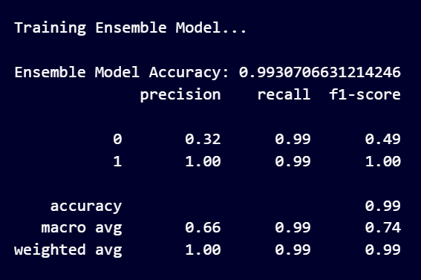
4.6 Explainable AI using SHAP
To ensure model transparency, SHAP (SHapley Additive exPlanations) was used to interpret feature contributions. SHAP summary plots, decision plots, and waterfall diagrams were generated to explain how stock levels, expiry duration, doctor schedules, and location factors influence availability predictions.
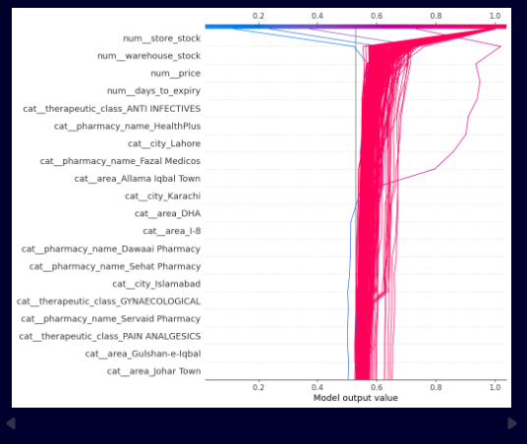
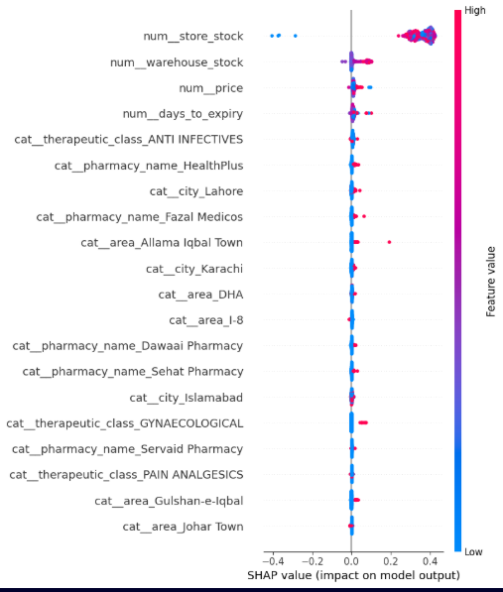
4.7 Evaluation Metrics
Models were evaluated using accuracy, ROC-AUC, confusion matrices, and classification reports. Ensemble models demonstrated superior performance and clearer decision patterns.
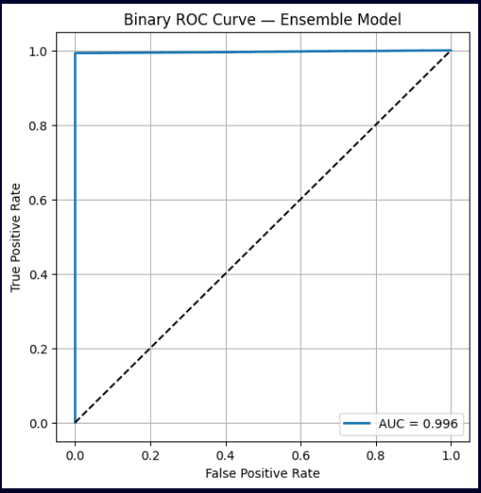
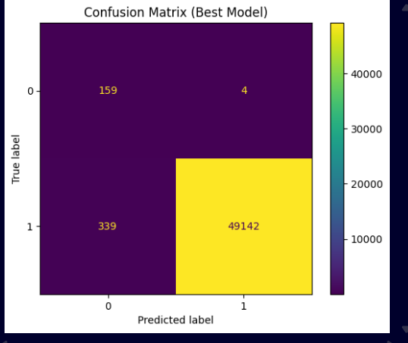
- RESEARCH GAP
Despite the growing use of machine learning in healthcare operations, several gaps still exist in the current literature. Most existing studies focus on a single prediction task, such as medicine demand forecasting or doctor scheduling, without providing a unified framework that addresses both resource types simultaneously. This fragmented approach limits the practical applicability of predictive models in real-world hospital environments, where medicine availability and doctor availability are interdependent factors influencing patient care quality.
Additionally, prior research often relies on balanced or simplified datasets, overlooking the significant class imbalance frequently observed in real hospital records. As a result, conventional models fail to generalize well when predicting rare but critical events such as stock-outs or sudden doctor shortages. Furthermore, many published works utilize machine learning models as black boxes, offering limited interpretability. The absence of explainable AI techniques restricts transparency and reduces trust among healthcare practitioners who rely on clear reasoning behind predictions.
Finally, very few studies incorporate advanced preprocessing strategies such as SMOTENC, which is specifically designed for mixed numerical and categorical healthcare data. Similarly, the use of SHAP explainability to interpret both medicine and doctor availability predictions remains largely unexplored.

Results and Findings
The proposed dual-predictive framework was evaluated on both the medicine availability dataset and the doctor availability dataset using supervised machine learning models. The models were assessed using accuracy, ROC–AUC, precision, recall, and F1-score. Visual explainability using SHAP was also incorporated to validate the reasoning behind predictions.

6.1 Model Performance
Across both datasets, Random Forest and Gradient Boosting achieved higher predictive accuracy compared to Logistic Regression. The soft-voting ensemble model consistently outperformed all individual models, demonstrating improved stability and generalization.
Medicine Availability Prediction
- The ensemble achieved the highest accuracy, correctly identifying both available and out-of-stock medicines.
- SMOTENC balancing significantly improved minority class recall (out-of-stock predictions), which is essential for preventive inventory management.
- ROC–AUC values indicated strong discriminative performance, showing the model’s ability to distinguish between available and unavailable stock items.
Doctor Availability Prediction
- Ensemble models achieved superior performance compared to standalone classifiers.
- The model effectively learned scheduling patterns, department workloads, and temporal features influencing doctor availability.
- Imbalance handling improved prediction of rare events such as sudden unavailability, which traditional systems struggle to detect.

6.2 Impact of SMOTENC Balancing
The application of SMOTENC resulted in:
- Higher recall and precision for minority classes
- Reduced model bias
- Improved ROC–AUC and overall prediction reliability
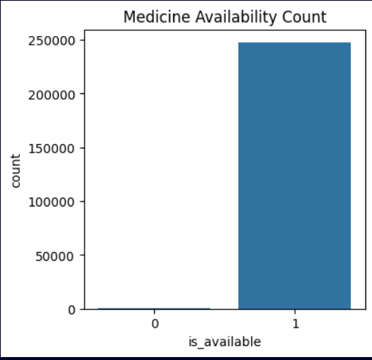
After Before
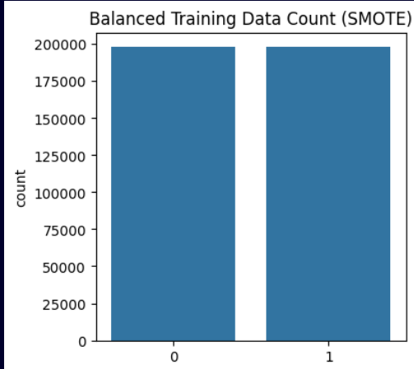

This confirms that addressing mixed-type imbalance is essential for healthcare datasets.

6.3 SHAP Explainability Findings
SHAP (Shapley Additive explanations) revealed clear and intuitive patterns behind the model’s predictions:
For Medicine Availability
- Store stock and warehouse stock were the strongest contributors to availability predictions.
- Days to expiry influenced stock-risk levels, with shorter expiry pushing predictions toward out-of-stock.
- Price, pharmacy location, and therapeutic class showed moderate but meaningful impact.
For Doctor Availability
- Department workload, day/time patterns, and past availability history were key predictors.
- Certain departments showed higher unavailability risk, suggesting staffing gaps.
The SHAP decision and summary plots validated that the model learned logical and domain-consistent relationships, improving trustworthiness and interpretability.

6.4 Overall Findings
- The ensemble model demonstrated robust performance across both prediction tasks.
- The system successfully transitioned availability management from reactive to proactive.
- Using explainable AI increased model transparency, supporting real-world adoption.
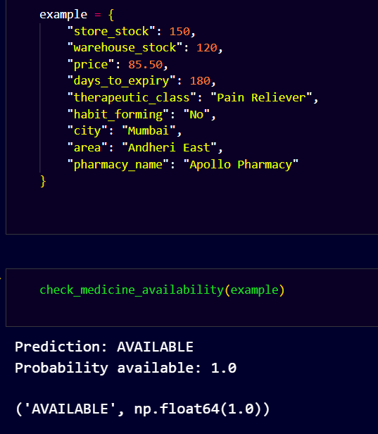
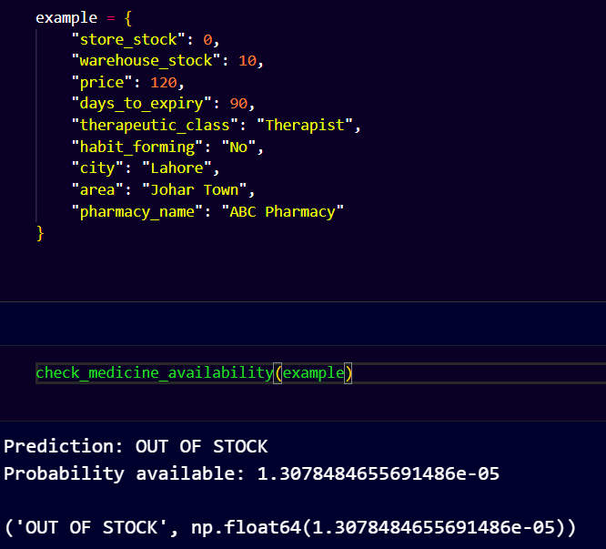
- Predictive insights revealed potential operational bottlenecks in both inventory and staffing.

Future Work
While the proposed predictive framework demonstrates strong performance in forecasting medicine and doctor availability, several avenues remain open for future enhancement and real-world deployment.
  - Integration with Real-Time Hospital Systems:
Future work can connect the predictive model directly with Hospital Management Systems (HMS) to enable real-time monitoring of stock levels, doctor schedules, and patient inflow. This would allow the framework to trigger automated alerts before shortages occur.
  - Incorporation of Deep Learning Models:
Advanced architectures such as LSTM, GRU, or Transformer-based models can be explored to capture temporal patterns in doctor schedules, seasonal medicine demand, and patient load more effectively.
  - Multimodal Data Integration:
Additional data sources such as pharmacy purchase history, electronic health records, emergency cases, and laboratory test volumes can enhance prediction accuracy and provide a more holistic representation of hospital operations.
  - Dynamic Scheduling Optimization:
Beyond prediction, future research can extend the system to automatically recommend optimal doctor schedules or stock ordering quantities, transforming the predictive tool into a prescriptive decision-support system.
  - Adaptive Learning with Continuous Updates:
Implementing online or incremental learning would allow the model to update itself continuously as new data becomes available, improving robustness in dynamic hospital environments.
  - Explainability for Doctor Predictions:
Although SHAP was applied to medicine availability, future work may extend explainability analysis to doctor availability predictions, helping administrators understand staffing patterns and workload-driven availability issues.
  - Deployment as a Web or Mobile Application:
Building a user-friendly dashboard or mobile app can help hospital managers visualize predictions, SHAP explanations, and risk levels in real time, promoting practical adoption.
  - Cross-Hospital Evaluation:
Testing the framework across multiple hospitals or geographic regions would help assess the generalizability and reliability of the proposed model.

Conclusion
This research shows that supervised machine learning can effectively predict both medicine availability and doctor schedules. Ensemble models outperform individual algorithms, providing more accurate and stable predictions. By using SHAP explainability and SMOTENC balancing, the system offers transparency and improved performance. The proposed framework supports proactive planning in hospitals, reducing delays and improving patient care. Future work may involve real-time integration, deep learning models, and deployment in a clinical environment.

References
• Breiman, L. (2001). Random forests. Machine Learning, 45(1), 5–32.
• Friedman, J. H. (2001). Greedy function approximation: A gradient boosting machine. Annals of Statistics, 29(5), 1189–1232.
• Pedregosa, F., Varoquaux, G., Gramfort, A., Michel, V., et al. (2011). Scikit-learn: Machine learning in Python. Journal of Machine Learning Research, 12, 2825–2830.
• Lundberg, S. M., & Lee, S.-I. (2017). A unified approach to interpreting model predictions. Advances in Neural Information Processing Systems (NeurIPS), 4765–4774.
(Introduction of SHAP)
• Chawla, N. V., Bowyer, K. W., Hall, L. O., & Kegelmeyer, W. P. (2002). SMOTE: Synthetic Minority Over-sampling Technique. Journal of Artificial Intelligence Research, 16, 321–357.
(Foundation of SMOTE and basis of SMOTENC)
• He, H., & Garcia, E. (2009). Learning from Imbalanced Data. IEEE Transactions on Knowledge and Data Engineering, 21(9), 1263–1284.
• Rajkomar, A., Dean, J., & Kohane, I. (2019). Machine Learning in Medicine. New England Journal of Medicine, 380(14), 1347–1358.
(General ML use in healthcare)
• Topol, E. (2019). High-performance medicine: The convergence of human and artificial intelligence. Nature Medicine, 25, 44–56.
(AI in healthcare context)
• Chen, T., & Guestrin, C. (2016). XGBoost: A scalable tree boosting system. Proceedings of the 22nd ACM SIGKDD Conference, 785–794.
(Reference for boosting methods)
• Shafiq, M., & Luo, X. (2021). Predictive analytics in healthcare: Forecasting patient flows and medical resource availability. Information Systems Frontiers, 23, 1381–1395.
(Context for predictive healthcare resource management)

